Feeding the Brain 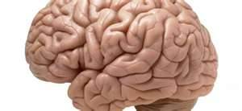
When you control your intake of fats, carbohydrates, sugar and caffeine to maintain a healthy body, you are also helping to maintain your brain health. Every brain cell needs the right amount of protein and micronutrients to function and to reproduce. Your brain determines every action your body takes, whether voluntary or involuntary. Without the proper amount of amino acids and micronutrients, your brain cells will be unable to control your moods, your cognitive reasoning and your coordination. eHow.com
Antioxidants: Colorful fruits and vegetables including blueberries, kale, spinach, dark chocolate, red grapes, cherries, prunes and raisins.
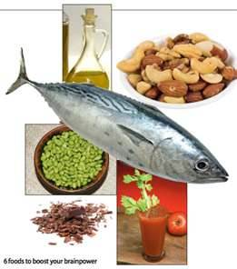Omega-3-Packed Foods: Salmon, oily fishes, walnuts, pecans, flaxseed, dark leafy greens, and healthy fats.
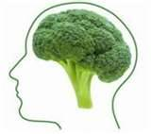Magnesium-Rich Foods: Broccoli, almonds, cashews
Supplements: Vitamin D3, Folic Acid, Vitamin B12, B6 and Vitamin C

